**Appendix Figures and Tables**

**Appendix Figure 1.** Data source description. (a) shows the same or similar posts may be published by different authors, (b) shows the same post may be published in both groups, (c) shows a real post in the full size (c-1) and in brief (c-2) that was crawled and processed through a data cleaning step (c-3), and (d) and (e) are the descriptions of the two groups as of December 2019.



**Appendix Figure 2.** Understanding of methods. (a) is an illustration of the force-directed layout network, (b) illustrates a stream graph (*x*-axis = time, *y*-axis = number of identified topics.

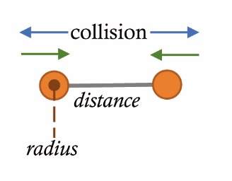 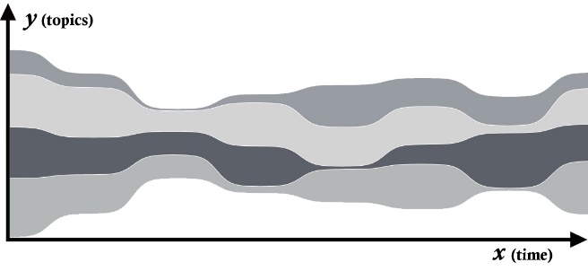

(a) (b)

**Appendix Table 1.** Moderator information for the two groups to indicate the sparsity of raw post data

|  |  |  |  |  |  |  |  |  |  |
| --- | --- | --- | --- | --- | --- | --- | --- | --- | --- |
| ***The Private group*** | | | | | ***The Public group*** | | | | |
| *Moderators* | *As an inviter* | *Posts* | *Followers* | *Got Likes* | *Moderators* | *As an Inviter* | *Posts* | *Followers* | *Got Likes* |
| S. Brian |  |  |  |  | 3Si MicroVentures | 204 |  | 1,370 | 1,331 |
| T. W. Byrd |  |  |  |  | C. Fernandes | 6,188 |  |  |  |
| M. H. Chew |  |  |  |  | J. Feimster | 2,567 | 512 | 1,239 |  |
| K. Chu |  |  |  |  |  |  |  |  |  |
| P. Dada |  |  | 204 |  |  |  |  |  |  |
| Y. Engelhard |  |  |  |  |  |  |  |  |  |
| J. Feimster | 2,453 |  | 1,239 | 2,453 |  |  |  |  |  |
| S. Garg |  |  | 62 |  |  |  |  |  |  |
| A. Grill |  |  | 62 |  |  |  |  |  |  |
| W. A. Hill | 11 | 1 |  | 11 |  |  |  |  |  |
| G. Horn |  |  |  |  |  |  |  |  |  |
| M. Kornak |  |  |  |  |  |  |  |  |  |
| J. L. D. Lee | 20 |  | 1,032 | 20 |  |  |  |  |  |
| J. Liu |  |  |  |  |  |  |  |  |  |
| G. Livingston |  |  |  |  |  |  |  |  |  |
| A. Mikhlin | 2 |  |  | 2 |  |  |  |  |  |
| K. Mller |  |  |  |  |  |  |  |  |  |
| R. Murphy |  |  |  |  |  |  |  |  |  |
| S. G. K. Naidu |  |  |  |  |  |  |  |  |  |
| A. Nathan |  |  |  |  |  |  |  |  |  |
| M. Porter |  |  |  |  |  |  |  |  |  |
| P. Sia |  |  |  |  |  |  |  |  |  |
| L. N. Timilsina |  |  |  |  |  |  |  |  |  |
| A. Todiwan |  |  | 96 |  |  |  |  |  |  |
| A. Zviagin |  |  |  |  |  |  |  |  |  |